SQL File 11
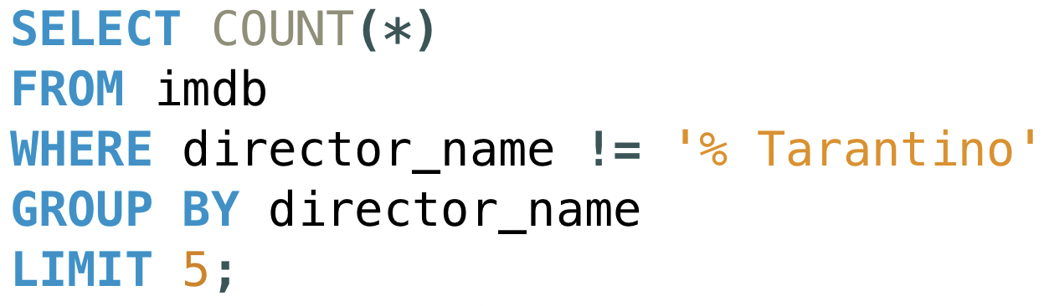

SQL File 12

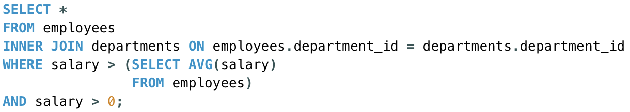

SQL FILE 13

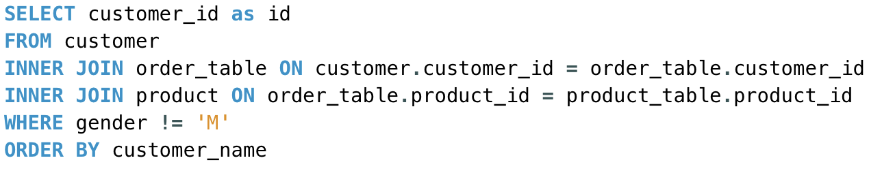

SQL file 14

